

**Tribhuvan University**

**Faculty of Humanities and Social Sciences**

**COLLEGE MANAGEMENT SYSTEM**

A PROPOSAL REPORT

**Submitted to**

**Department of Computer Application**

**Bajra International College**

**Jorpati, Kathmandu**

***In partial fulfillment of the requirements for the Bachelors in Computer Application***

**Submitted by:**

BCA 7th Semester

Under the Supervision of

**Name of the Supe**

# **ACKNOWLEDGEMENT**

This project has been prepared to gain practical knowledge in accordance with the Bachelor level BCA syllabus, focusing on the development of the College Management system. We are thankful to our supervisor and family for the support we received throughout the journey of working on this project. We are grateful that through this application, we have been able to gain skills that will impact our lives.

We would especially like to thank all our supervisor, whose invaluable assistance and suggestions were crucial to the success of this project. Their guidance directed us on the right path during our research, and their patience and extensive experience provided us with essential insights. The knowledge and skills we have gained under his mentorship will undoubtedly serve us well in our future endeavors. We will always be grateful for his support and guidance.

Yours sincerely,

*BCA 7th Semester*

Contents

**ACKNOWLEDGEMENT** i

**LIST OF FIGURES** iii

**Introduction** 1

**1. Introduction** 1

**2. Problem Statement** 1

**3. Objectives** 2

**4. Methodology** 2

1. Requirement Identification 2

2. Development Methodology 2

3. Feasibility Study 4

4. ER Diagram 4

5. DFD Diagram 4

**5. Gant Chart** 6

**6. Expected Outcomes** 6

References 7

# **LIST OF FIGURES**

Figure 1: Agile Methodology 3

Figure 2: ER Diagram 4

Figure 3: DFD Level 1 5

Figure 4: DFD Level 2 5

Figure 5: Gant Chart 6

# **Introduction**

# **1. Introduction**

The College Management System is a comprehensive web-based application designed to streamline and automate various academic and administrative tasks within an educational institution. It simplifies the management of student registration, course allocation, faculty management, fee collection, and examination processes, ensuring a more organized and efficient system. By centralizing data and reducing manual paperwork, the system improves accuracy, minimizes errors, and enhances overall productivity for both staff and students.

This system offers a user-friendly interface that allows students to register for courses, view academic progress, and make fee payments online. Faculty members can manage class schedules, update student attendance, and upload exam results, while administrators can oversee all institutional operations, including generating reports and managing financial records. Additionally, the College Management System enhances communication by providing real-time notifications and announcements, keeping all stakeholders informed and engaged.

By digitizing core processes, the College Management System not only saves time but also promotes data security and reliability. Its scalable architecture ensures it can be expanded to accommodate larger institutions, making it a cost-effective and sustainable solution for modern educational management.

# **2. Problem Statement**

The current manual system for managing college activities involves significant paperwork and consumes a lot of time. Some of the issues include:

* Time-consuming student registration and result management.
* Inefficiency in fee collection and attendance tracking.
* Difficulty in accessing student records and faculty information.
* Lack of proper communication channels for students and faculty.

The proposed College Management System will address these challenges by automating the entire process and centralizing data for better management.

# **3. Objectives**

The main objectives of the College Management System are:

* To develop a web-based system for student registration, course management, and attendance tracking.
* To provide a secure platform for fee payments and financial management.
* To centralize student and faculty data for easy access and management.
* To enhance communication between students, faculty, and administrators.
* To generate reports for decision-making and academic progress tracking.

# **4. Methodology**

## 1. Requirement Identification

The system will consist of the following core modules:

* **Admin Management Module:** Manage student admissions, faculty records, course allocations, and institutional policies, ensuring smooth administrative operations.
* **Account Management Module:** Automate fee collection, manage student payments, faculty payroll, generate receipts, track financial transactions, and maintain accurate accounting records.
* **Examination Management Module:** Manage exam schedules, record student grades, generate result reports, and ensure secure access to exam results.

## ****2.**** Development Methodology

Agile is an iterative project management and software development approach that helps teams deliver value to their customers faster and with less trouble.

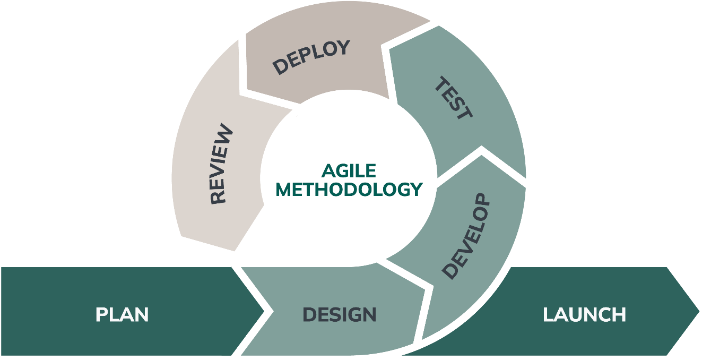

Figure 1: Agile Methodology

1. **Requirement Analysis:** All the requirements for making a Travel & Tours Management System in java including time and resource needs, are listed. These consist of an IDE for coding, a database for storing and retrieving data, and an OS for running the program.
2. **Design:** The design of this Travel & Tours Management System was done using Lucid Chart which is an online tool to design high and low-fidelity images/ diagrams.
3. **Development:** The development phase consists of coding a function or a module. In this, every class was made for the system, and their functions were added to the next iterations testing: After development of each module it was tested and if any test failed it was revised and the problem was found out and tested again until it is solved.
4. **Deployment:** The system was tested and reviewed and verified by the subject teacher i.e., our supervisor through every iteration in the development process

## 3. Feasibility Study

* **Technical Feasibility:** The system will be developed using PHP, MySQL, HTML, CSS, and Bootstrap technologies, all of which are readily available and supported by most systems.
* **Operational Feasibility:** The College Management System will streamline operations by automating manual processes, improving accuracy, and reducing human error.
* **Economic Feasibility:** The system will reduce costs associated with paperwork, physical storage, and manual labor, making it a cost-effective solution.

## 4. ER Diagram

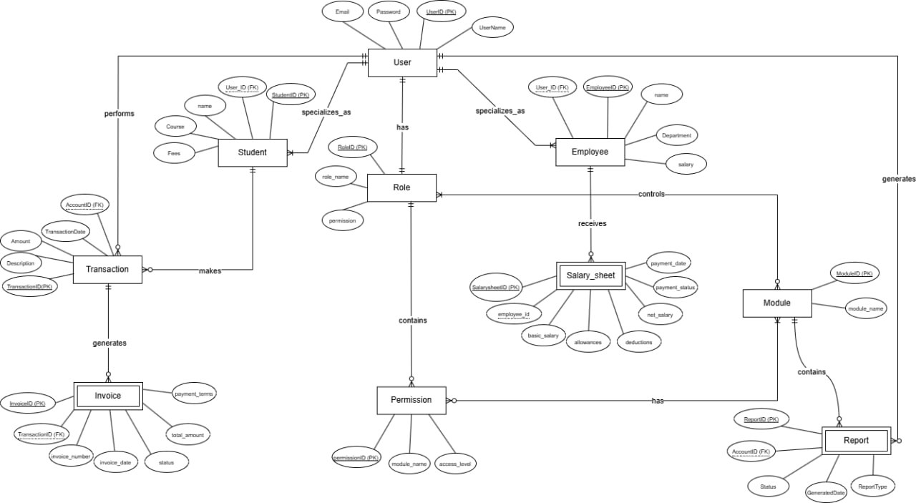

Figure 2: ER Diagram

## 5. DFD Diagram

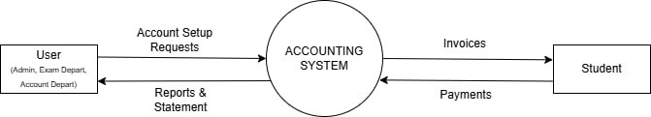

Figure 3: DFD Level 1

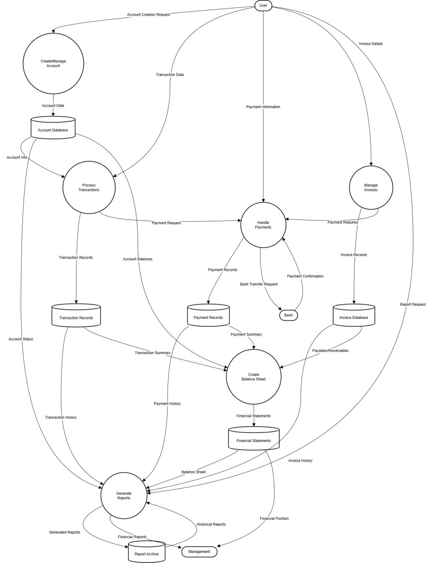

Figure 4: DFD Level 2

# **5. Gant Chart**

Figure 5: Gant Chart

# **6. Expected Outcomes**

The College Management System will:

* Automate student registration, attendance, and grading processes.
* Improve efficiency in fee collection and financial reporting.
* Enhance communication between all stakeholders.
* Ensure better data security and reduce manual errors.
* Provide a scalable solution for future expansion.

# References

|  |  |
| --- | --- |
| [1] | https://www.iitms.co.in/college-erp/. |
| [2] | https://www.ijraset.com/research-paper/college-management-system. |
| [3] | https://chatgpt.com/c/678e5caa-668c-8012-9d78-5adc04177e82. |